Trevor Cargile

Professor William Nericcio

English 220

26 March 2015

First Impressions and the Power of Words

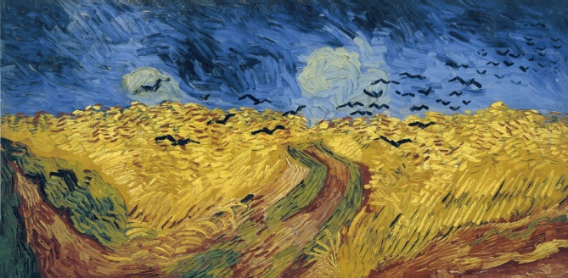 Dion Boucicault's *The Octoroon* introduces us to a world where African Americans and Native Americans live as second class citizens (worse yet, in some cases, they are treated worse than animals). Bound up with this institutionalized devaluing of specific human "types" is an aesthetic determination; here, the color of one's skin or one's accented language gets assigned a negative value, a place of dishonor, on the hierarchy of "objective" human value. In the subsequent paragraphs of my essay, I will use John Berger et al's critique of the visual in *Ways of Seeing* to explore Boucicault's parallel critique of racism in *The Octoroon.*Ultimately, I hope to show that Berger's ideas about seeing and Boucicault's ideas about race are foundations to prove the influence words have in altering the first impressions of faceless, seemingly real personas.

"This was the last picture that Van Gogh painted before he killed himself" (Berger 28).

vs.

Without viewing the actual play, readers of *The Octoroon* have to rely on the character's dialogue to illustrate what they feel is an accurate representation of that person; that faceless persona animates itself into one that the reader can picture in their minds. Berger conveys this same idea of captions and sentences accompanying illustrations as if they were parasites polluting their host, essentially changing them from their uncontaminated form. While discussing Van Gogh and his final piece of art before committing suicide, Berger writes, "It is hard to define exactly how the words have changed the image but undoubtedly they have. The image now illustrates the sentence" (Berger 26). The presence of a description renders an opposite portrayal of a once calm nature landscape into one of a depressed artist finalizing his thoughts and feelings into a piece of art; that is to say its first impression modifies itself to better represent the associated description.

The same can be said for the dialogue that exemplifies the main characters in *The Octoroon*. Without any omnipotent description from a narrator, the characters present themselves in the way that they speak. Every character speaks relatively the same way - proper English blended with some southern twang - except for those who are colored. In Boucicault's play, people who are not white communicate utilizing broken English and colloquialisms popularized by the slave community in the 1800's. Terms like "bomn'ble fry", "war gwine", and "you stan' dah" (Boucicault 22,38,44) produce a negative connotation of an uneducated, illiterate individual, which gives the impression that all colored people are unintelligent.

The situation gets even worse for the character Wahnotee, "an Indian chief of the Lepan tribe" (Boucicault 21). He speaks one to two words at a time like he doesn't have the intellectual capacity to gather thoughts on more than one subject. Wahnotee portrays himself to be less than human or as Zoe puts it, "an honest creature"(Boucicault 30), as to discredit his human existence. Deliberately destroying a camera because of his uncertainty about emerging technology portrays Wahnotee as a savage and uncivilized monster that only Native American people would do. The way in which one presents themselves is how others will perceive them, much like how Berger explains, "The meaning of an image is changed according to what one sees immediately beside it or what comes immediately after it" (Berger 29), which in this case the image represents a human being. Although this kind of behavior would have been expected from an audience hailing from this time period, their language holds the stereotypical taint of the past - a stain on this piece of literature, forever associating illiteracy and simple mindedness with people who aren't white.

Another damaging display of racism that takes place in *The Octoroon* concentrates on the common belief that slaves and other non-Europeans were merely objects. Slave masters looking down condescendingly on their "property", displaying them like items in an auction. This recurrent theme of owner and owned isn't news though. As Berger delves deep into late seventeenth century art, he discusses the recurrent theme of the conqueror versus the colonized: "These relations between conqueror and colonized tended to be self-perpetuating. The sight of the other confirmed each in his inhuman estimate of himself" (Berger 96). It's not just the actions of the slaves that portray them to be beastly, or inhuman, but by virtue of how the masters regard their slaves. Slave owners, even without any justification, arrive at the conclusion that they possess animal-like versions of themselves just by how they look. Those feelings are their first impressions; they don't need words or actions to alter those impressions like before. Even being one-eighth black carries a negative association with it as reveled by M'Closky in *The Octoroon*: "That one drop of black blood burns in her veins" (Boucicault 44). The color black, meaning not pure, suggests a sort of evil coursing through Zoe just because of her heritage.

Judgment and stereotypes based on skin color don't apply to only colored people though. When M'Closky is being accused of murdering Paul he proclaims to Pete, "No--no, If I must die, give me up to the law; but save me from the tomahawk. You are a white man; you'll not leave one of your own blood to be butchered by the redskin?" (Boucicault 72). By M'Closky's logic, those who aren't the colonized need to defend themselves against those who are; this means Pete is automatically considered a conqueror in this case because he has white skin. Discrimination, or favoritism, based on the color of one's skin continues to communicate the significance of first impressions - something that has driven hatred and slavery throughout history.

First impressions dictate the process in which an individual, group, or nation is viewed by the rest of the world. In John Berger's *Ways of Seeing* and Dion Boucicault's *The Octoroon,* first impressions derive themselves from what the eye distinguishes as well as the words, or spoken language, that surrounds that visual. It's these impressions that have driven societal norms in the past, present, and the ongoing future.

Works Cited

Berger, John. *Ways of Seeing.* London: Penguin Books, 1972. Print.

Boucicault, Dion. *The Octoroon*. Peterborough: Broadview Press, 2014. Print

Van Gogh. *Wheatfield with Crows*. 1853-18090. N.p.